Community-Based Adaptation
FAST FACTS

Grantee: CUNA Association
Type of organization: NGO
Number of participants: 75 families
Location: Communities: Huajasiya, Cacachi, Cavinchilla, Tilacoca and Cojatapampa the Municipality of Carabuco, Bolivia
CBA Contribution: $35,000 USD
Project Partners: Municipal Government of Carabuco
Co-financing: $51,032 (in cash); $8,196 (in-kind)
Project Dates: March 2009 – August 2010
BOLIVIA
Recovery of tarwi seeds in four communities of the Carabuco Municipality that surrounds the Titicaca Lake

BACKGROUND
The Community-Based Adaptation Programme (CBA) is a five-year UNDP global initiative, largely funded by the Global Environment Facility (GEF) along with other donors. Delivering through the GEF-Small Grants Programme (SGP) and UNDP Country Office, the goal of the Project is to strengthen the resiliency of communities addressing climate change impacts. UNDP partners with the United Nations Volunteers (UNV) programme to enhance community mobilization, recognize volunteers’ contributions and ensure inclusive participation around the project, as well as to facilitate capacity building of partner non-governmental organizations (NGOs) and community-based organizations (CBOs). Testing the Vulnerability Assessment Reduction (VRA) and other community-engagement tools, the Project is generating invaluable knowledge and lessons for replication and upscaling. The Government of Japan, the Government of Switzerland, and AusAID provide additional funding.
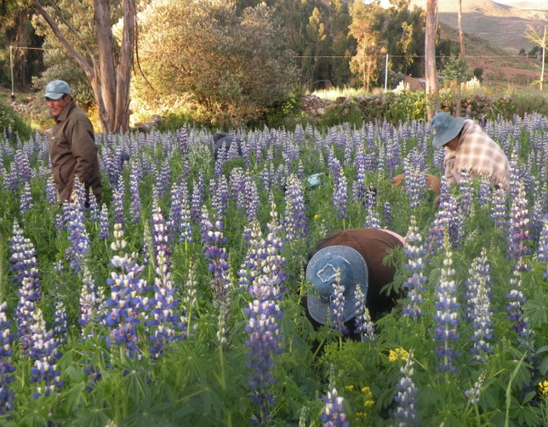
The CBA project “Recovery of tarwi seeds in four communities of the Carabuco Municipality that surrounds the Titicaca Lake” focuses on communities of Huajasiya, Cacachi, Cavinchilla, Tilacoca and Cojatapampa of the La Paz Department in the western border of Bolivia. The project area is located in a heterogeneous geographical zone with altitudes ranging from 3,820 to 4,482 meters above the sea level with steep hills, rocky slopes, sandy soil and plains. It has a mountain climate with dry and cold winters with occasional snowfalls and cool and rainy summers. The annual registered rainfall is 675 mm, occurring mostly in the summer time (December to March), and come with strong winds. Wind erosion causes severe water evaporation from the sandy soils and degradation of the vegetable cover. Since the community members rely on agriculture (of potatoes, beans, peas, ocra, barley and lupine) as the primary source of their food consumption and income, climate change driven impacts put their livelihoods and the ecosystems they rely on at risk
Community members perform inspection activities on selected tarwi seen plots
Contact information: Project Management Unit at cba@undp.org
220 East 42nd St., 21st Floor New York, NY 10019 Tel: (646) 781-4402
For more information about CBA or CBA projects visit: www.undp-adaptation.org/project/cba

CLIMATE CHANGE RISKS
Climate change projections developed by the IPCC AR4 (2007) and the First National Communication to the UNFCCC in Bolivia suggest that temperatures in Bolivia will continually increase as the rainfall become more intense and erratic. The temperature change is likely to be higher in the upper regions, possibly leading to significant changes in glacier mass and increased evapotranspiration, and consequently aridity. The warming quasi-periodic climate pattern of El Nino- Southern Oscillation (ENSO) is another cause for the increasing rainfall variability and increasing aridity in Bolivia. Documented glaciers retreat, due to increase of temperatures, may increase seasonal runoff in the short term and increase dependency on seasonal rainfall for water supply in the medium and long term. Climate change-driven events lowers the water availability, especially in the highlands, leads to crop failure, soil erosion, biodiversity loss, mudslides, droughts and floods.
.
PROJECT DESCRIPTION AND ADAPTATION SOLUTIONS
The CBA project aims to strengthen the local agricultural system through the use of certified local seeds (lupine seeds) and appropriate technology as an adaptation measure to reduce the communities’ vulnerability to climate change risks. Through a participatory approach, the communities are able to increase crop production in a sustainable way and protect their natural resources. The project increases the adaptive capacity of local communities through the following activities:
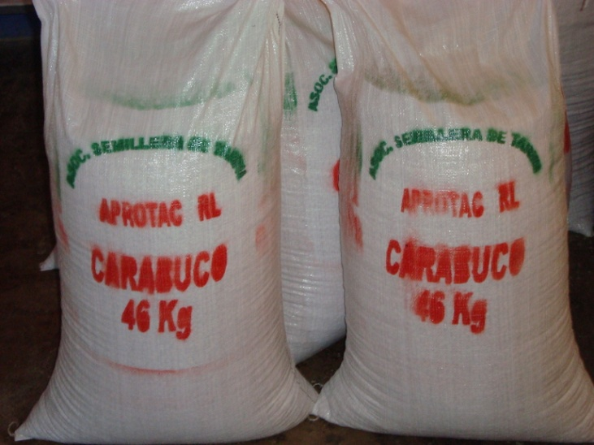
- A local-level adaptation plan is designed which includes the identification and organization of the certified lupine seed producers and the Organic Statute for rules and regulations for the association of seed producers. The plan and rules correspond to the will of the community members of meeting common goals to reduce their vulnerability to climate change impacts.
- Participatory training sessions and workshops are held on 1.) organizational management, 2.) application of standards for the production of certified seed, and 3.) administration and basic business management.
- A savings and credit intervention model is created to support the income-generating activities of the project. Proceeds from the sales of production outputs from the project goes to a fund and are used for the seed producers to cope with losses caused by climate change and/or expand/improve the technology for crop production. The fund is formalized by a joint account at a financial institution based on the regulations for fund usage developed through a participatory approach.
Increase in Final products: Seeds produced from the protection of Tarwi seeds from pests.
- Support for legal procedures of the organization are provided.
- Training sessions and field work are held to improve the communties’ skills on the production of certifed seeds which include the identification of the most suitable plots of lands for seed production, installation of seed plots, management of lupine seed crop, pest control for crop plant seedlings and an agricultural calendar.

This project increases the community awareness and adaptive capacity through comprehensive and participatory approach on recovering local seeds and the sustainable resource management to protect their food security, livelihoods and natural resources from increasing temperatures, evapo-transpiration and aridity brought on by climate change.
FOCUS ON...
Global environmental benefit
The project promotes global environmental benefits by re-introducing a local variety of tarwi seed and other seed varieties that are resilient to climate change impacts. Additionally, the training on sustainable water and soil management provided to the community members will contribute to their resiliency to climate change adverse impacts as well as reduce the climate-change risks. Best practices will be integrated into the Program for the Conservation and Sustainable use of the Important Biological Diversity in Agriculture (FMAM), which is related to community-based management of natural resources.

Community participation and sustainability
The ability of the inhabitants involved to adapt to environmental changes depends on their understanding of climate change and its capacity to distinguish between natural impacts, human pressures and climatic factors. In this regard, the project was developed and implemented through a participatory approach. Awareness-raising workshops are held to understand the community members’ perception on climate change, know their problems, strengths and wekanesses and help them identify the most appropriate adaptation actions such as monitoring and evaluation systems for water flow changes and the water quality in the Moro Moro River.

Additionally, an intervention model of fund usage is established to strengthen the financial skills and abilities of the communities and help ensure their sustainability. Through an induction process and social awareness workshops, the communities learn how to manage proceeds from sales of production outputs into a fund to cover losses caused by climate change and / or expand or improve technology for crop production. The project’s income-generating activities contribute to the communities’ sustainability.

Policy Influence
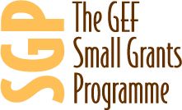
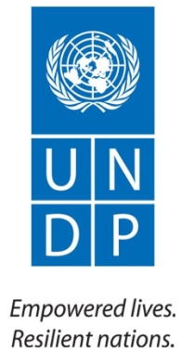
Local policy makers are involved in the project. Their contibution, as well as other organizations involvement in the region, is a clear importance in ensuring that the agricultural policies in La Paz and neigboring regions are updated and include the successful and innovative practices introduced by the project.

