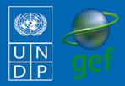
Community-Based Adaptation
FAST FACTS

Grantee: Facultad de Agronomía de la Universidad Mayor de San Andres
Type of organization: NGO
Number of participants: 1,277
Location: Huancané, Tuquia y Huncallani Communities in the Battallas Municipality of La Paz, Bolivia
CBA Contribution: $35,000 USD
Project Partners:
Co-financing: $56,443 USD (in cash)
Project Dates: October 2009 – October 2011
BOLIVIA
Adapting to Climate Change through water resource management and afforestation in the Battalas Municipality

BACKGROUND
The Community-Based Adaptation Programme (CBA) is a five-year UNDP global initiative, largely funded by the Global Environment Facility (GEF) along with other donors. Delivering through the GEF-Small Grants Programme (SGP) and UNDP Country Office, the goal of the Project is to strengthen the resiliency of communities addressing climate change impacts. UNDP partners with the United Nations Volunteers (UNV) programme to enhance community mobilization, recognize volunteers’ contributions and ensure inclusive participation around the project, as well as to facilitate capacity building of partner non-governmental organizations (NGOs) and community-based organizations (CBOs). Testing the Vulnerability Assessment Reduction (VRA) and other community-engagement tools, the Project is generating invaluable knowledge and lessons for replication and upscaling. The Government of Japan, the Government of Switzerland, and AusAID provide additional funding.
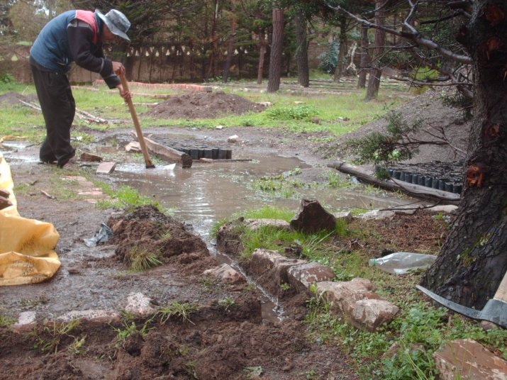
The CBA project “Adapting to Climate Change through water resource management and afforestation in the Battalas Municipality” is located in the highlands of the La Paz Department in the western border of Bolivia. The project focuses on the Huancane, Huncallani and Tuquia communities who highly depend on agriculture (potatoes, beans, quinoa, oca and barley) and livestock (cows, sheep, pigs, llamas, chickens and rabbits), as the primary source of their livelihood. On a smaller scale, they also rely on fishing, cheese production and reed production. The project site is located 3850-6300 meters above sea level and has low soil fertility and low vegetation cover. Due to its altitude, latitude and location, it experiences strong winds, frost, hail, as well as abrupt temperature changes from day to night with high radiation during the day and freezing temperatures at night. Water scarcity is pre-dominant in the area, as drought occurences is simultaneous with freezing. With continuous and unpredictable climate changes, the area experiences less rainfall, more hailstorms, stronger polar winds and droughts. These factors exacerbate conditions in the project sites and lead to agricultural and livestock damage as well as water scarcity for human and animal consumption and irrigation. Since forest cover is almost non-existent in the area, agriculture and livestock are not protected from incresaingly stronger winds, hailstorms and high temperatures. Additionally, frequency of hailstorms and frost occurences have increased and are damaging the crops even before the seeds can flower. With only one harvest season for agricultural production, all these factors jeopardize food security, water availability and ecosystem conservation in the area.
Restoring community plots damaged by hailstorms.

CLIMATE CHANGE RISKS
Bolivia has experienced many extreme weather events brought about by El Nino/La Nina-Southern Oscillation (ENSO). New studies show that climate changes will continually intensify in Bolivia, critically impacting water resources. In the periods of 1941-1961 and 1990-2004, there has been a 15% decrease in precipitation in the Bolivian Amazon, and up to 25% in the valleys of Santa Cruz. Similarly, the average increase of 0.15 ° C per decade, recorded in the Andes in 1950-1994, led to the dramatic glacier melting below the level of 5400 meters in the north. The snowy Chacaltaya mountains has lost 95% of its area, and 99% of its ice since 1940. If this situation continues, climate change could affect Bolivia and water resources in an unprecedented way (WB, 2009).
Contact information: CBA Project Management Unit at cba@undp.org
220 East 42nd St., 21st Floor New York, NY 10017 Tel: (646) 781-4402

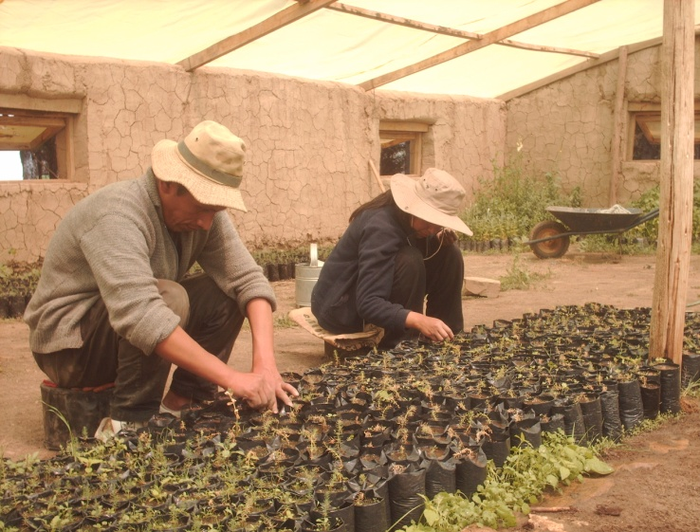
Glacier melting due to increasing temperatures, may increase seasonal runoff in the short term and increase dependency on seasonal rainfall for water supply in the medium and long term. Climate change-driven events such as glaciers melt and erratic rainfall lowers the water availability, especially in the highlands, leading to crop failure, soil erosion, biodiversity loss, mudslides, droughts and floods.

PROJECT DESCRIPTION AND ADAPTATION SOLUTIONS
The CBA project aims to strengthen the communities’ resiliency to climate change through awareness-raising workshops and capacity-building activities on natural resource management. Using a participatory approach, the project is implemeneted by the Facultad Agronomia de la Universidad de San Andres, the project partner NGO. The project increases the adaptive capacity of local communities through the following activities:

- Rehabilitation of forest nurseries, covering 1.6 hectares, by planting 60,000 seedling trees increase vegetation cover and crop production.
Community members have increased the plant and shrub seeds outputs by 60% in the nurseries, which once planted and established, guarantee land and agriculture restoration in river basins and areas upstream. These improvements lead to increases in agricultural production in the project areas.
- Improvement and refurbishing of water resources to optimize water allocation used for the irrigation of seedlings and saplings by: 1.) creating retro-fitted infrastructures in the natural springs that supply water to main storage tanks; 2.) reconditioning the water channel conductors and storage tanks; 3.) improving the water piping in the nurseries.
- Rehabiliation of riverbeds, combined with soil conservation practices, increases the water infilitration to soils.
- Strengthening community solidarity and imparting skills in project implementation through proper nursery management, watershed management and protection of water sources.

This project increases the community awareness and adaptive capacity through comprehensive and participatory approaches on sustainable natural resource management, with a strong focus on water resources. Their enhanced skills and increased knowledge help them protect their livelihoods, food security and natural resources from climate change. Additionally, empowerment and accountability within the communities increase motivate the community members to share the best practices with neighboring communities.
FOCUS ON...
Global environmental benefit
The project aims to generate global environmental benefits through 1.) carbon sequestration through the restored river basins; 2.) soil conservation techniques; and 3.) the rehabilitation of the ecosystem and biodiversity leading to protecting endemic fauna and flora. Finally, it contributes to addressing global greenhouse gas emissions by capturing CO2 through biomass accumulated by trees as they grow.

Community participation and sustainability
All community members, along with communal and municipal authorities, were involved in the project development and implementation. All community members, inlcuding students from primary and secondary schools, receive at least 4 trainining courses on climate change issues, natural resource management and income generation activities. All activities are implemnted in accordance to the rules and obligations that were agreed upon in community meetings and overseen by a community committee or board administrator..

Policy Influence
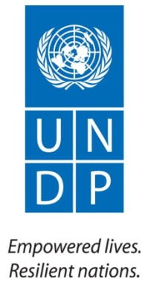
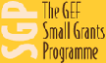
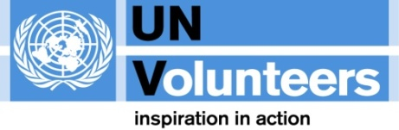
Municipal government evaluates the progress of the project on a regular basis as stipulated in binding agreements. Best pracitces are integrated into local policies. Additionally, the Mayor of Batallas visits the project sites and advocates for best practices to be integrated in national policies.
For more information about CBA or CBA projects visit: www.undp-adaptation.org/project/cba
Further information, lessons learned, and experiences gathered from climate change adaptation activities globally are available at the Adaptation Learning Mechanism: www.adaptationlearning.net

